# Date:17/08/2020 PRACTICAL NO. 1

**Aim :-** Install Selenium IDE; Write a test suite containing minimum 4 test cases for different formats.

# Installation of Selenium IDE in Chromium Browser

**Step-1 :-** Launch Chromium browser.

**Step-2 :-** Search for Selenium IDE in the ”chrome web store”.

**Step-3 :-** Select ”Add to Chrome” Button which will lead to chromium pop-up asking for permission to add the extension, click ”Add Extension” button.

**Step-4 :-** Chromium will automatically download and install the extension. Which can be accessed from the ”Extensions” Icon Button on the Navigation Bar.

**Step-5 :-** Clicking on the selenium IDE icon, the extension will open a new window with the selenium IDE.

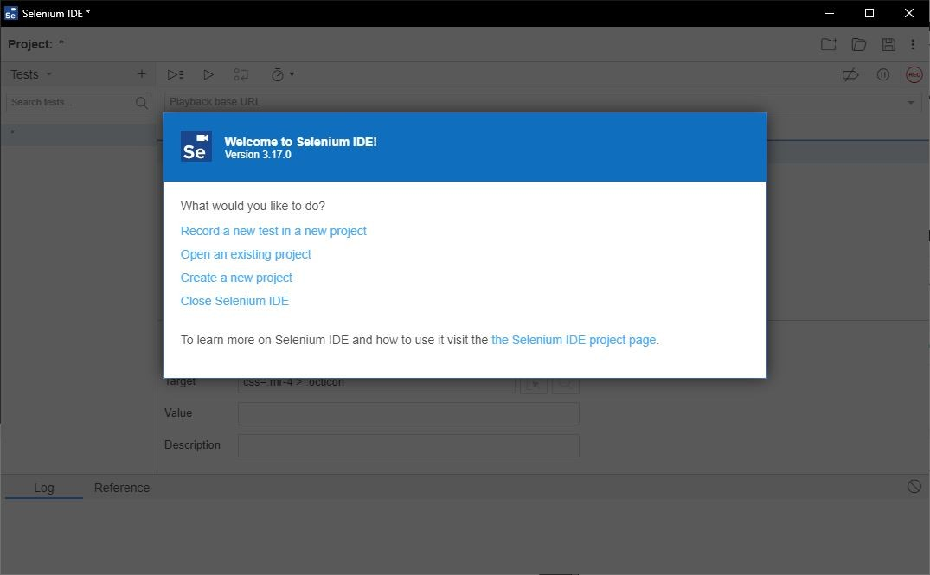

Figure 1: Selenium IDE Window

# Creating/Recording and Running a Test Suite

**Step-1 :-** Launch the Chromium browser and open the selenium IDE extension.

**Step-2 :-** When the Welcome screen of selenium IDE is visible, select the option ”create a new project”.

**Step-3 :-** Give an appropriate name to the project and rename the untitled default test case to another appropriate title.

**Step-4 :-** Set the ”Playback base URL” to the URL value of the website/webpage you wish to test.

**Step-5 :-** At this point you have two choices where in you can either manually type the test steps in the IDE or let selenium record the steps for you by clicking the ”Record button ON”.

**Step-6 :-** We will first Record the steps using selenium’s Record functionality. On click- ing the ”Record button ON” or keyboard shortcut ”Ctrl-U”.

**Step-7 :-** A new window will pop up with the base URL provided by us earlier , this window is special because selenium will record our mouse clicks and key inputs. *Be careful not to reveal any sensitive information in the record mode.*

**Step-8 :-** Now perform the testing on various elements of the HTML document either by direct clicks/key inputs or by selecting various methods from the ”right-click selenium drop-down menu” which will provide various options for assert various elements and validate various values.

*→*

*→*

**Step-9 :-** You can try out filling forms, dummy login credential test and a lot more.

**Step-10 :-** After you are done with the test script click on ”Stop Recording” button or keyboard shortcut ”Ctrl-U”.

**Step-11 :-** Save the test script by clicking on ”Save project icon” or keyboard shortcut ”Ctrl-S”.

**Step-12 :-** Next save the script in the desired folder path and selenium will download the ”.side” file to the same .

**Step-13 :-** You can reopen the saved Project by clicking ”Open Project icon” or key- board Shortcut ”Ctrl-O” and selecting the ”.side” file from the desired location.

**Step-14 :-** To run the test click on ”Playback icon” button and selenium will run the test as per the script and log all the events in the window. You can verify which steps succeed and which ones fail with Error messages as well.

**Step-15 :-** The test script can be written manually as well and will produce the same results.

**Selenium IDE Features**

1. Menu Bar Menu bar is positioned at the top most portion of the Selenium IDE

interface. It allows the user to change name/open project/save project and more.

Figure

2: Menu Bar 2. ToolBar The toolbar offers options such as play test/record test

and play all the tests in test suite. More advanced features such as

breakpoints/debugger are also available

3. Test case panel This panel allows the user to add/delete /modify the selenium

commands. The Command, Target, and Value entry fields display the currently

selected command along with its parameters. These are entry fields where you

can modify the currently selected command. The first parameter specified for a

command in the Reference tab of the bottom pane always goes in the Target

field. If a second parameter is specified by the Reference tab, it always goes in the

Value field. The Comment field allows you to specify in a human readable format

a description of the current command.

4. Navigation Panel Navigation between test cases and test suites is done

through the right hand side of Selenium IDE. Clicking on Tests with the small caret

will open up a menu. When saving the project will be saved as the new .side

format, which will include all test cases and suites combined. It is refered to as a

project.

5. Console Panel The bottom pane, called Console Panel for it’s similarity with

web devtools, is used for different utility functions: Log, Reference, depending on

which tab is selected.

# Test Case 1 :

**Test URL :** https://login.mailchimp.com/

Selenium Commands used :

Command-1 :-set window size Command-2 :-click Command-3 :-type

Command-4 :-close

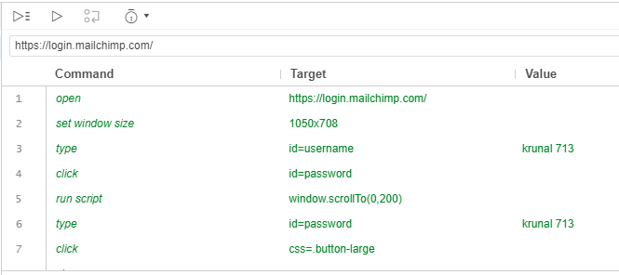

Figure 2: First Test Script Executed Successfully

# Test Case 2 :

**Test URL :** <https://www.shopify.in/tour/ecommerce-website>/

Selenium Commands used :

Command-1 :-open Command-2 :-type Command-3 :-click Command-4 :-close

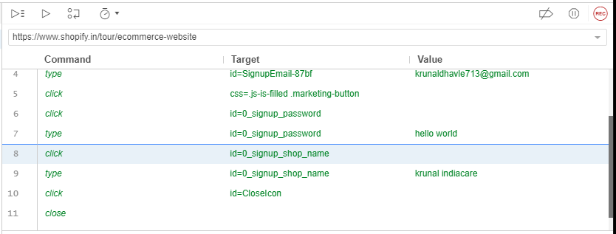

Figure 3: Second Test Script Executed Successfully

# Test Case 3 :

**Test URL :** http://www.google.com/

Selenium Commands used :

Command-1 :-open Command-2 :-mouse Command-3 :-send Command-4 :-click Command-5 :-close

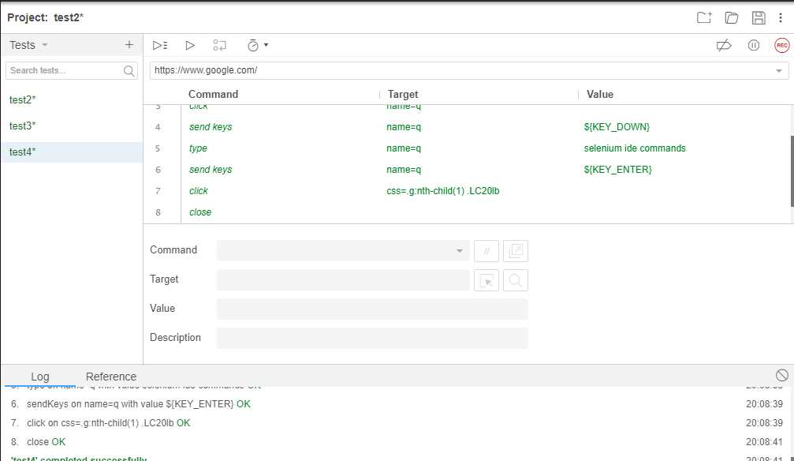

Figure 4: Third Test Script Executed Successfully

# Test Case 4 :

**Test URL :** https://www.netflix.com/in/Login

Selenium Commands used :

Command-1 :-wait for element Command-2 :-click Command-3 :-assert checked Command-4 :-type Command-5 :-close

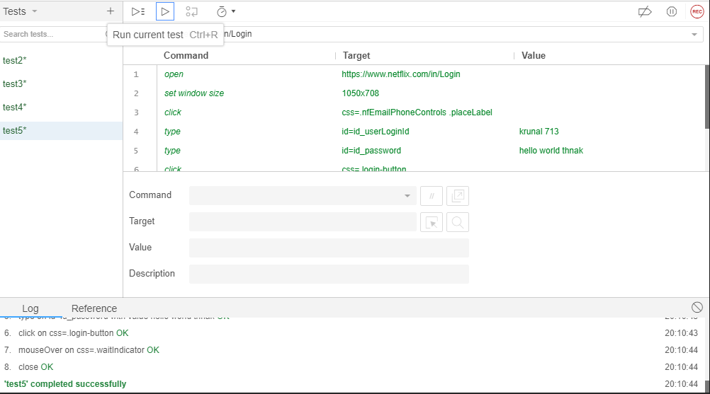

Figure 5: Fourth Test Script Executed Successfully